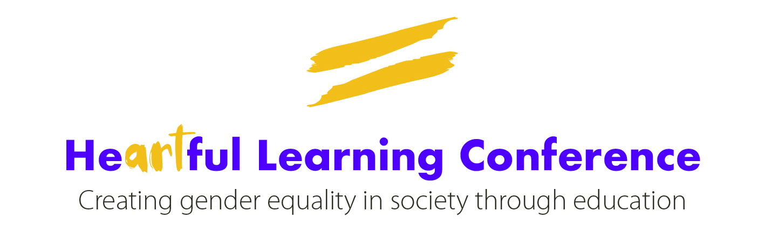

CALL FOR INDIVIDUALS / ORGANISATIONS TO DELIVER CONFERENCE WORKSHOPS

HeARTful Learning Conference
Creating Equality in Society through Education

Friday 8th November, 9.00am – 4.30pm (Registration 8.45am)
The University of Chester, Warrington Campus, WA2 0DB

Guidance:

The HeARTful Learning conference, lasting a full day, will be an opportunity to share innovative approaches and articulate both practice and research into how education and the arts together can and should be a vehicle for creating greater gender equality in society. It will also explore how to tackle the widespread issues of violence against women and girls (VAWG) and poor mental health for boys and men.

The Philip Barker Centre for Creative Learning at The University of Chester warmly invites individuals and organisations to submit proposals for a conference workshop for attendees, delivered in an engaging, experiential, practical format and lasting 45 minutes. Proposals should be linked to your own work or experience, and should support how to develop and deliver gender equal Early Years and Primary education.

We have a particular interest in proposals around the following themes:

- Moving from knowing to acting in relation to gender equality
- Proactively changing culture and embedding gender equality consciously through the curriculum, culture and beyond the school gates
- Ways in which the arts and creativity promote and develop gender equality
- The link between current educational culture of partial masculinity and femininity, which feeds VAWG and poor mental health for boys and men
- Power - how to help children navigate all facets of power so they can act from “power within”, rather than “power over”
- Creating clearer awareness and acceptance of non-binary gender identities

Who can apply:

Submissions are welcome from anyone interested in creating substantive equality in society, from school leaders and teachers/training teachers, to organisations and individuals working in arts and education.

Format and attendees:

We are seeking workshop proposals that can be delivered to conference attendees in a creative, experiential and practical way. Workshops should last for 45 minutes. Attendees will include a range of education practitioners (such as Early Years and primary teachers and arts education professionals), influencers (such as those already working in the field of gender equality), and speakers (from a range of related backgrounds).

(Workshop Proposal Form overleaf.)

WORKSHOP PROPOSAL FORM

Please carefully read the guidance notes above before completing this Workshop Proposal Form.

ABOUT YOU

Name:

Affiliation(s) (e.g. name of employing organisation, university, school):

ABOUT YOUR WORK

Introduction – the context of the organisation and/or the team involved, the background to the activity and the aims of the work:
Approach – an explanation of what is/was undertaken and how you do/did the work, including any formal evaluation
Outcomes – what is happening / has happened as a result of the work undertaken?

WORKSHOP PROPOSAL

Proposed title of workshop (this can change):

Please briefly outline a plan for your workshop (i.e. structure, set-up, content, length):
3 key points  What 3 key points will participants take away from your workshop? | 1.  2.  3.

The submission deadline is 5.00pm on Sunday 20th October 2019.

Please submit completed forms to Joanna Freeman at pbccl@chester.ac.uk

